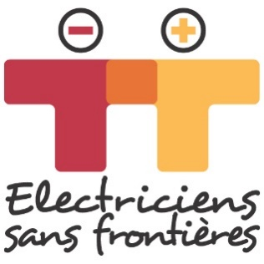

YOU HAVE A PROJET, WE WOULD LIKE TO KNOW MORE…

Thank you for getting in touch with us.

This document is to enable us to identify the main features of the project and study the fit between our mission and your proposal.

Electriciens sans frontières is an international NGO that mobilizes volunteers who put their expertise at the service of sustainable actions to provide access to energy, water and economic development (lighting, water pumping, economic activities, etc.) within the framework of development projects that benefit the poorest populations. We intervene in support of project management, leading training and/or project management.

If your project meets our criteria it will be shared with our volunteer network through the various regional offices that carry out the projects. The volunteer team will then contact you to prepare together a complete file (technical and socio-economic study, preparing an implementation file based on any selected options, fundraising, and implementation).

Electriciens sans frontières is neither a donor nor an organization that provides equipment.

Warning: being contacted by a volunteer does not guarantee the project will proceed. The file must be reviewed and approved by our various committees.

Electriciens sans frontières

Application date : Cliquez ici pour entrer une date.

CONTACT

Organisation:Click here to add text.
Date of creation: Click here to add text.
Address: Click here to add text.
Examples of projects carried out: Click here to add text.
Intervention area(s) : Click here to add text.
Contact person: Click here to add text.
Role in the organisation: Click here to add text.
E-mail address: Click here to add text.
Phone number: Click here to add text.
Website: Click here to add text.

How did you hear about Electriciens sans Frontières
Click here to add text.

THE PROJET

Summary and origin of the projet:
Click here to add text.
Country: Click here to add text.
Region: Click here to add text.
Tow/ Village: Click here to add text.
Is the village connected to the electricity grid? Click here to add text.
What are its water sources? Click here to add text.
Type of area: ☐urban ☐suburban ☐rural

Type of structures affected by the projet (maternity, dispensary, school, etc):
Click here to add text.

What are the needs and who expressed them?
Click here to add text.

What is the goal of the project in a few lines?
Click here to add text.

Description of the beneficiaries / users of the project? How will their living conditions be affected by the projet?
Click here to add text.

What you need from Electriciens sans frontières:
Click here to add text.

Partners involved in the project:
Click here to add text.

Other potential partners :
Click here to add text.

Total yearly planned budget in euros (expenses and income):
If possible give detail about the part of the budget that might concern Electriciens sans frontières.

How will you make this project sustainable ? Are their any village comitees or management groups already in place?
Click here to add text.

Coherence of the action with local regional and national policies :
Are local authorities aware of the project ? IS the project supported? By whom?

